**Manual Testing for Method runContinuous()**

**IDENTIFIER: Test Case 1**

**TEST CASE:**

Test if method runCountinous() gives the same outputs before and after modification

**PRECONDITIONS:**

Creating a 15 * 15 world to start the game using original runContinuous() method.

**EXECUTION STEPS:**

1. Click cells like following:

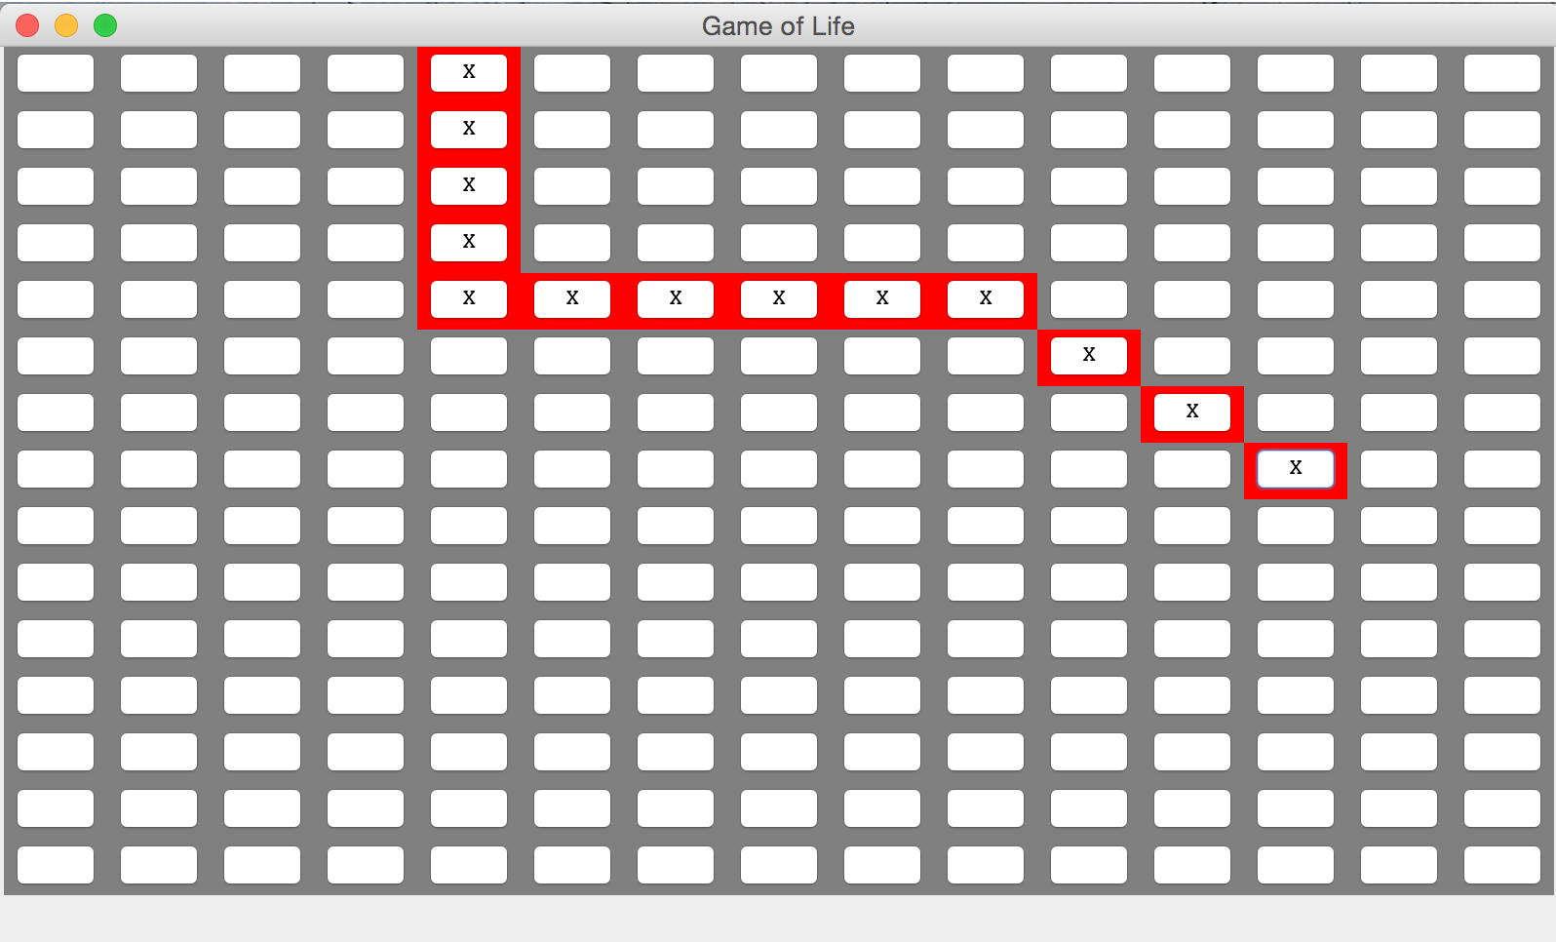

2. Click on Run Continuous button.

3. Click on Stop button after 10 seconds.

4. Record living cells position on the interface and take a screenshot:

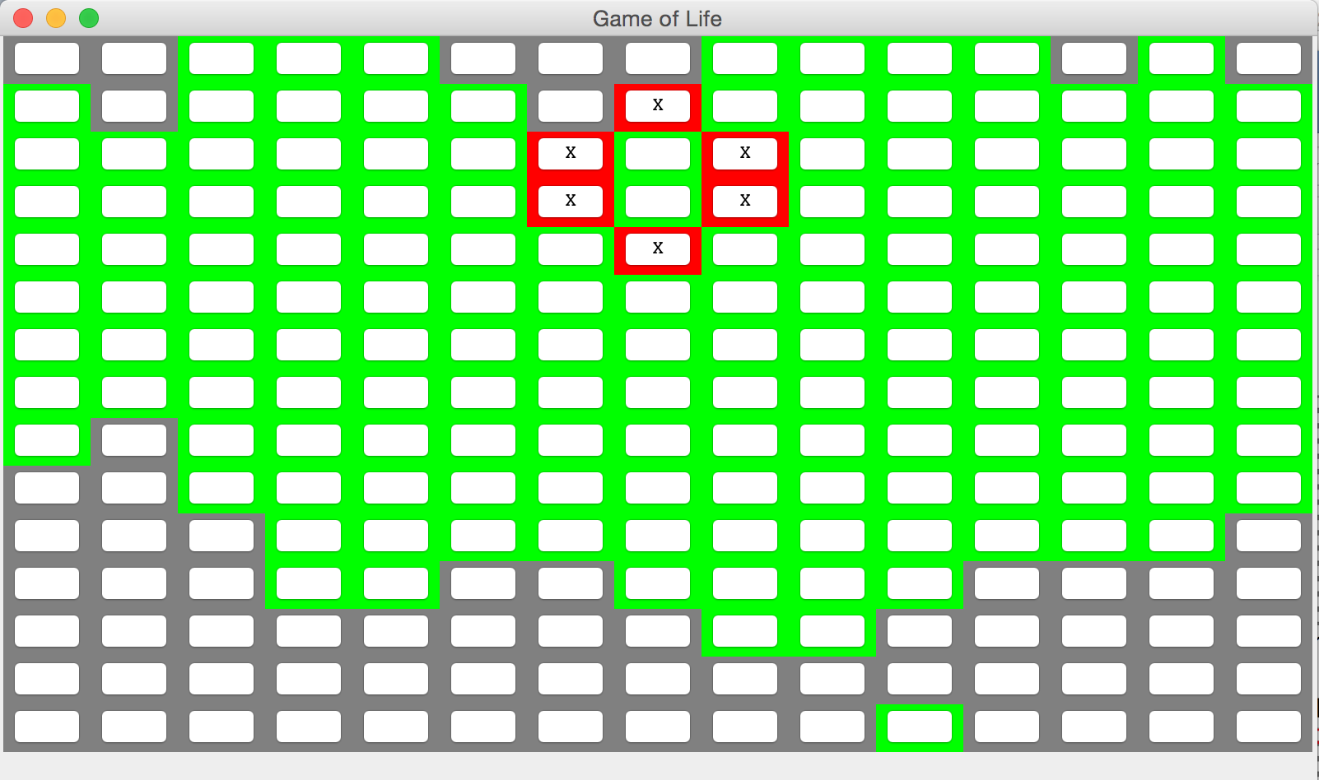

5. Exit Game of Life.

6. Modify runContinous() method, and start the game again. Then start the game by

creating a 15 * 15 panel.

7. Click the exact cells as before.

[4,0], [4,1], [4,2], [4,3], [4,4], [5,4], [6,4], [7,4], [8,4], [9,4], [10, 5], [11, 6], [12, 7]

8. Click on Run Continuous button.

9. Click on Stop button after 8 seconds.

**POSTCONDITIONS:**

The cells are on the exactly the same position as it has been recorded before, and status of the cells are the same as those which runs with the original runContinuous() method.

**IDENTIFIER: Case 2**

**TEST CASE:**

Test if method runCountinous() gives the same outputs before and after modification

**PRECONDITIONS:**

Creating a 15 * 15 world to start the game using original runContinuous() method.

**EXECUTION STEPS:**

1. Click cells like following:

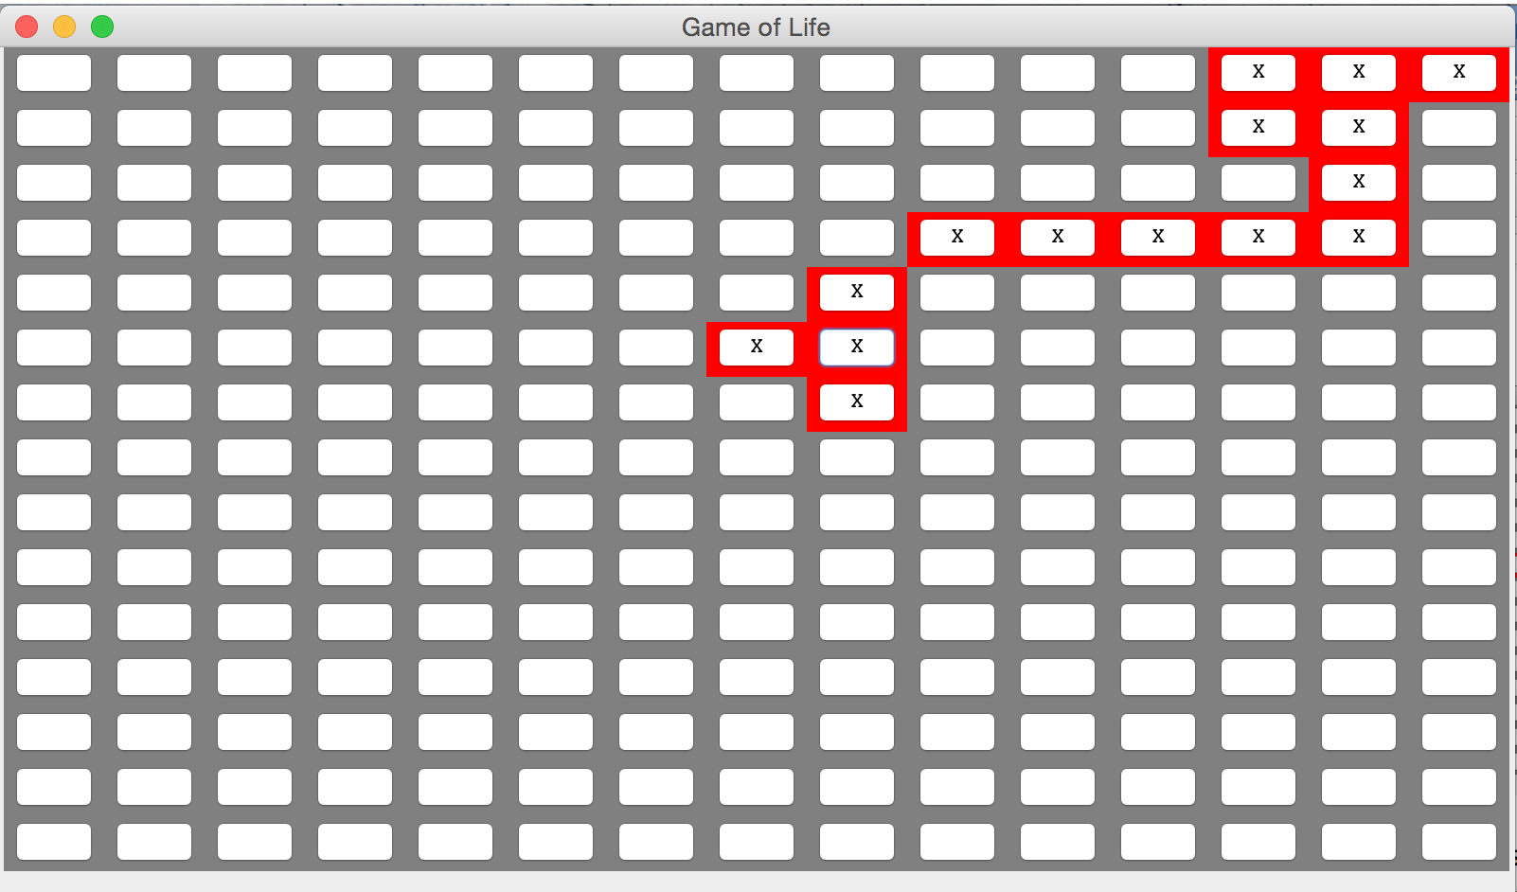

2. Click on Run Continuous button.

3. Click on Stop button after 16 seconds.

4. Record living cells position on the interface and take a screenshot:

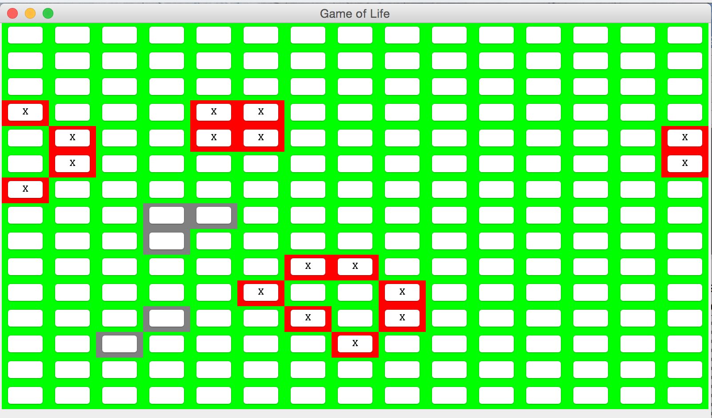

5. Exit Game of Life.

6. Modify runContinous() method, and start the game again. Then start the

game by creating a 15 * 15 panel.

7. Click the exact cells as before. [7,5], [8,4], [8,5], [8,6], [9,3], [10,3], [11,3], [12,0], [12,1], [12,3], [13,0], [13,1], [13,2], [13,3], [14,0]

8. Click on Run Continuous button.

9. Click on Stop button after 13 seconds.

**POSTCONDITIONS:**

The cells are on the exactly the same position as it has been recorded before, and status of the cells are the same as those which runs with the original runContinuous() method.

**IDENTIFIER: Case 3**

**TEST CASE:**

Test if method runCountinous() gives the same outputs before and after modification

**PRECONDITIONS:**

Creating a 15 * 15 world to start the game using original runContinuous() method.

**EXECUTION STEPS:**

1. Click cells like following:

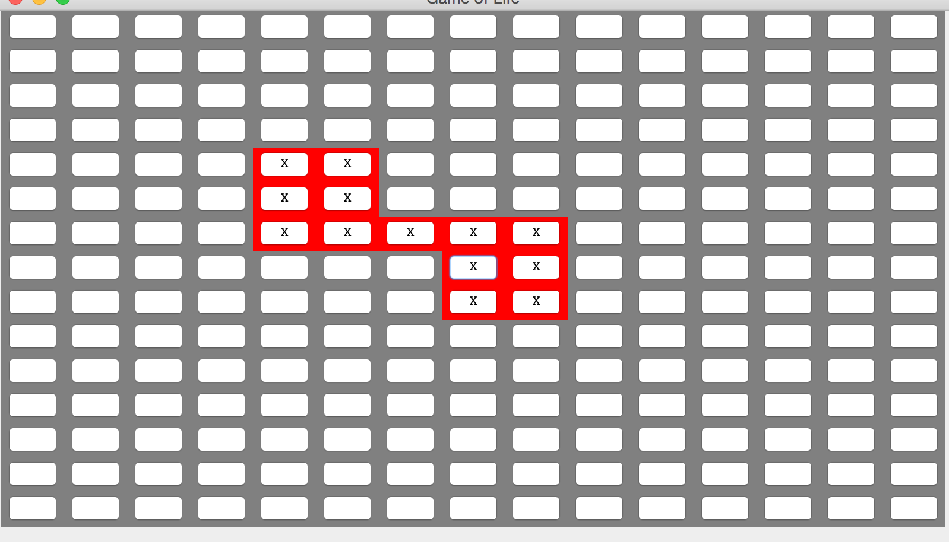

2. Click on Run Continuous button.

3. Click on Stop button after 2 seconds.

4. Record living cells position on the interface and take a screenshot:

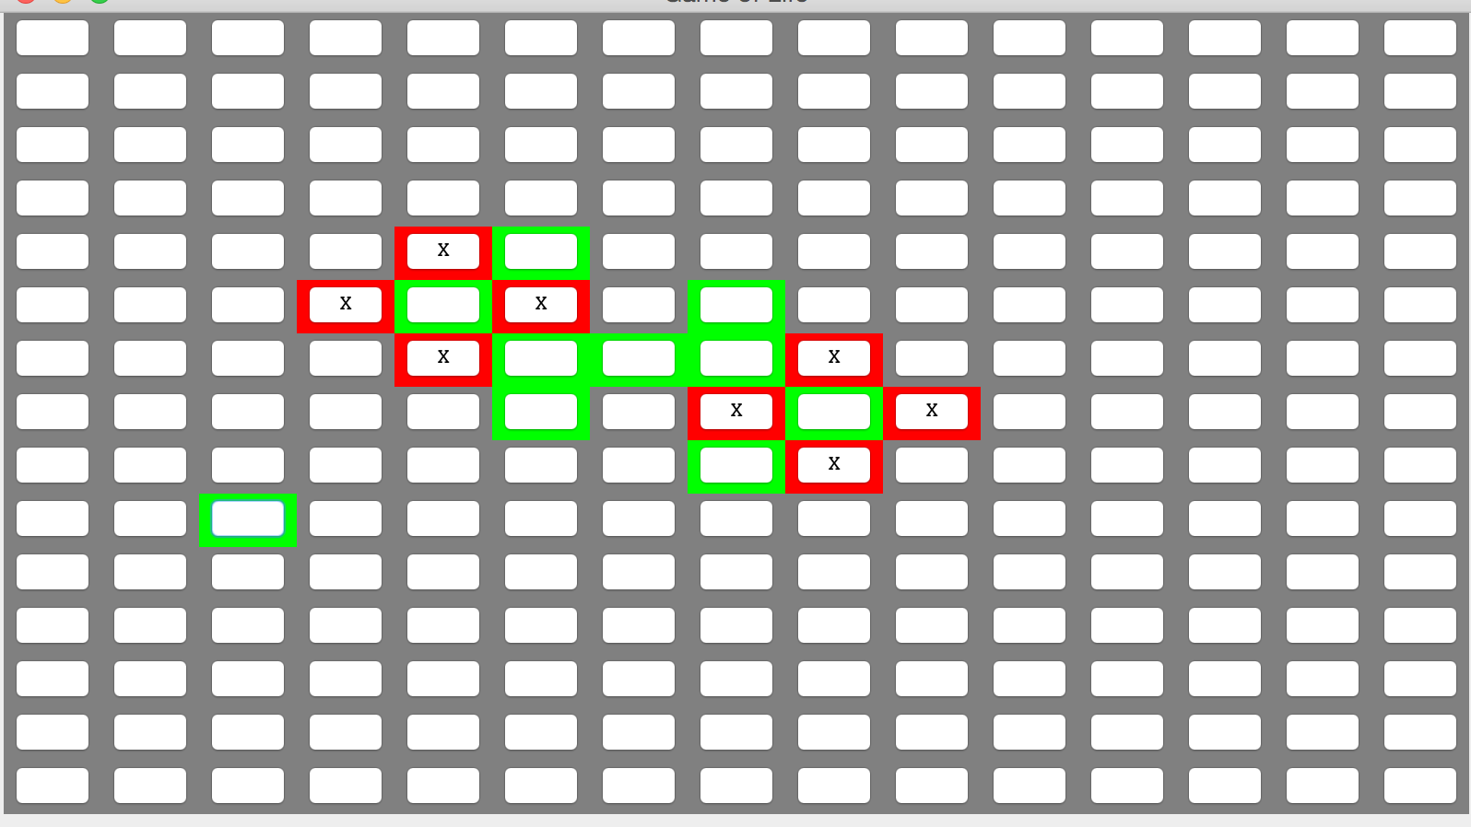

5. Exit Game of Life.

6. Modify runContinous() method, and start the game again. Then start the game by

creating a 15 * 15 panel.

7. Click the exact cells as before. [4,4], [4,5], [4,6], [5,4], [5,5], [5,6], [6,6], [7,6], [7,7], [7,8], [8,6], [8,7], [8,8]

8. Click on Run Continuous button.

9. Click on Stop button after 1 seconds.

**POSTCONDITIONS:**

The cells are going through the exact pattern as it has been recorded before, and status of the cells are the same as those which runs with the original runContinuous() method.